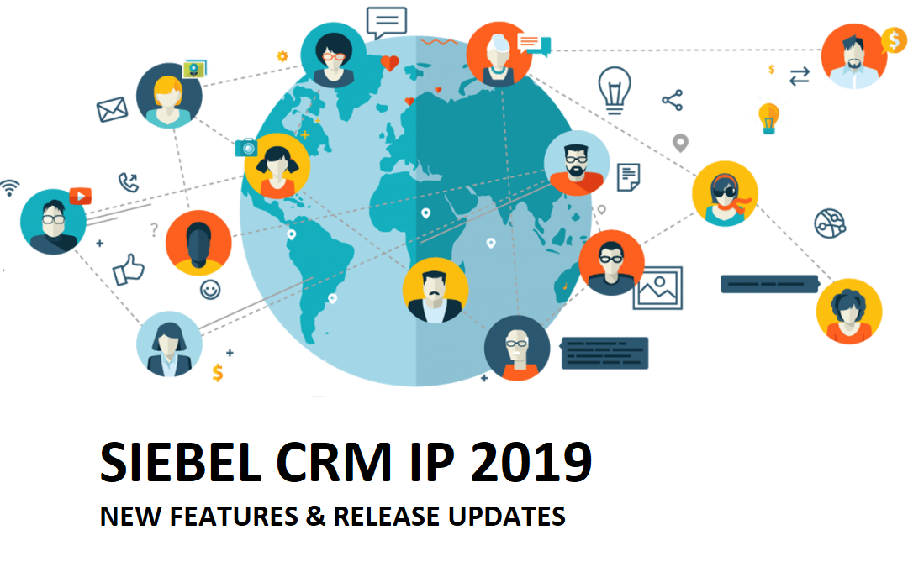

PURPOSE
This document provides an overview of features and enhancements included in Oracle Siebel CRM Release Updates. Its intended purpose is to help you assess the business benefits and for planning the implementation of the product features described. The new features and enhancements relate to the period defined by this document for delivery in Siebel CRM Release Updates.

- Siebel CRM Roadmap
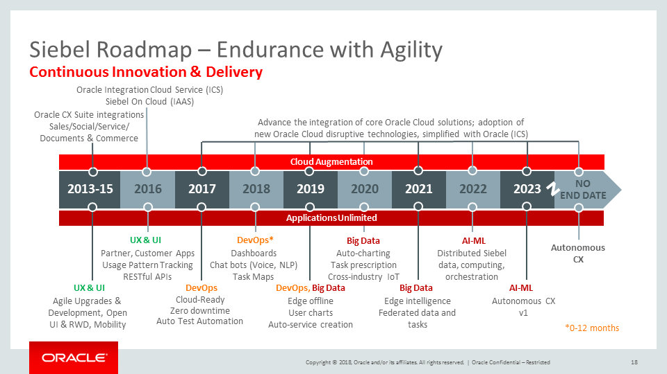

- Digital Transformation with latest Siebel CRM

CUSTOMER EXPERIENCE

The following features pertaining to improving customer experience are planned for delivery.

Data Visualization
Studies have shown that the human mind typically processes Images faster than text, and it is much more meaningful to translate data that is traditionally displayed in forms and spreadsheets into easily understandable visuals to see the “big picture” or convey the intelligence. The Data Visualization process can be categorized into three steps:

- Creation of Intuitive Visuals: The first step is displaying the data in an easy-to-read manner so that the message comes across to your users. The application server can process large volumes of data and supports sophisticated queries to ensure optimal performance. A robust IDE enables developers or business analysts to create visualizations, such as charts and infographics, with minimal effort.
- Personalization: Users may set preferences and move content around the dashboard to match their roles/interests. Personalization greatly improves the user experience as it allows the user to control the interaction.
- Automation: Instead of the user personalizing the site such that it is optimal for them, the application interprets usage patterns, trends, and correlations, then intelligently personalizes a dashboard to the user’s needs.

The new features planned for delivery mark the first step in journey towards data visualization. Listed below are the key features:

- Prebuilt visualization components (such as infolets) that allow a user to quickly consume information at a glance, timelines for chronological interactions, various charts to slice and dice the data to your preference, and many more.
- A visual IDE to compose your dashboard layout, drag-and-drop capability, and most importantly compose new visual components with minimal effort
- Preview dashboards by selecting the application of your choice whether it is an employee application, partner application, or customer self-service application.
- The ability to leverage the same visualization controls across various devices, browsers, and form factors.

Dashboards

Dashboards provide a summary of the most important information for users. They cater to various user roles, channels, or organizations and can be tailored to accommodate the differences between various industries. In addition to prebuilt dashboards, our intention is to provide all the tools needed to create these dashboards as quickly and efficiently as possible.

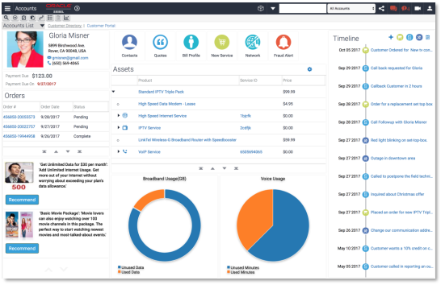

Dashboard Auto-Generation
In order to ease the process of generation of dashboards and 360 degree views and to enhance the developer’s experience, Siebel application will have a feature to create dashboard automatically based on predefined rules, templates and by metadata mining. The auto generation process will create a base dashboard which can be further enhanced by developers.

Dashboard Personalization
Users of the application prefer to see their dashboards with specific set of information and in preferred visualizations. This feature will allow users to customize their dashboards and save their preferences for future use. They would also be able to share their dashboard with others in the community.

Sales Dashboard (Cross Industry)

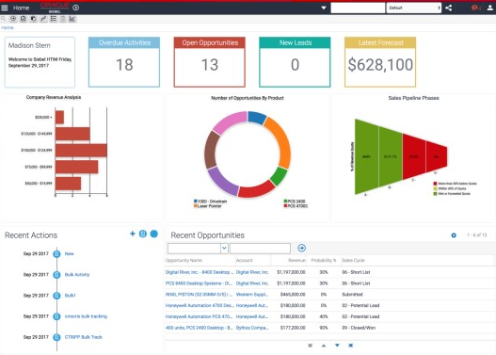

User Experience
The following Open UI framework features will be added to improve usability:

- Automatic availability of Tile and Map visualizations
- Capability to load multiple Siebel CRM portlets simultaneously in an external application
- Improved UI responsiveness via simultaneous loading within a single UI
- Multi-tab browsing of different Views in the same Siebel CRM application open in different tabs
- Improved Usability with multiple browser tabs accessing the same Siebel session
- UI Right Click and Open - Ability to "Right Click and Open" Siebel navigation links
- Improvement in UX for editing of hierarchies, including those involving multiple Object styles, across Siebel functional areas

There are multiple new controls planned for delivery in the product that will enhance the consumption of information stored in Siebel CRM. Some of the new controls are:

- Infolet: Visual representation of aggregated data from one entity – a number or text. Example: Number of Open Opportunities.
- Timeline: Display of multiple entities (e.g. opportunities, activities, SRs, etc.) arranged in chronological order in one visualization.
- Hierarchy: Display of four hierarchically associated entities in one visualization to get a complete view of all events/interactions.

- Multi-Hierarchy UI - includes support for the multi-hierarchy control (depicting households, contacts and entities associated with the contact), show vertical and horizontal scroll bars and control wizard.

Contact Photo WebService
Ability to call an API to associate a photo with a Contact.

OpenUI Portals
The Siebel eTraining, Siebel Helpdesk and other standard interactivity applications are planned to be made available in Open UI.

Reporting for Customer Portals
Enable Oracle BI Publisher reports to be generated on customer facing portal applications via a report icon and supporting views. The reporting capability will be similar to the current reporting functionality. This feature will require an Oracle BI Publisher integration and relevant licenses.

Customize URL
Ability to provide a customized URL to align the Siebel CRM application website to corporate branding standards.

Accessibility
We will continue to provide leading accessibility. As always Accessibility compliance will be outlined in the Siebel VPAT at http://www.oracle.com/us/corporate/accessibility/vpats/vpats-siebel-162956.html

Oracle Live Experience
Oracle Live Experience Cloud is a SaaS application that enables enterprises to modernize customer experience with digital engagement. A standard Siebel CRM integration with Oracle Live Experience can help drive digital transformation initiatives. By extending the familiar Siebel CRM UI with Oracle Live Experience (LX) it’s possible to deliver new context-aware, modern digital engagement channels including voice, video and screen sharing to their customers.

Key benefits:
- Improve customer experience
- Deliver modern engagement to your customers
- Ability to upsell during engagement
- Opportunity to differentiate from competitors
- Cloud agility & innovation
- Leverage existing Siebel CRM investment

The following features are provided with the Oracle Live Experience integration:

- Easy to integrate widget providing in-app engagement channels (contextual voice, 1 / 2 way video, screen share)
- Proactive engagement scenarios using customer context
- Intelligent routing using customer context
- Modern associate portal and digital collaboration tools (escalation to video, screen sharing, spotlighting & annotation)
- Initiate scheduled meetings via an auto-generated URL
- Recording, transcription & interaction store across all channels
- Insight and analytics. Optimized RTC cloud platform
- Oracle Live Experience is GDPR compliant

Call Center agents view of Oracle Live Experience integration with Siebel CRM
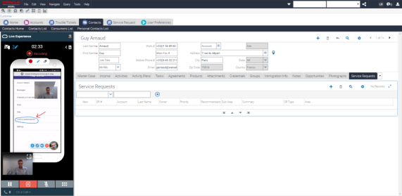

Siebel Mobile
The Siebel Mobile Framework is being enhanced to provide a more consistent user experience whether working online or offline and to ensure the minimum number of gestures (clicks, taps, etc.) is required to complete a task. The key abilities provided in the enhanced framework are:

- Batch Synchronization - Mobile users can continue to work in the offline mode and data will be synchronized, without any user intervention on a regular interval as long as the connectivity is there. This will ensure that users have the latest data on their devices. This will enable a dispatcher to send the latest Service Request to the field technician and he/she will be able to get the data automatically on their device. This will enhance the user experience for the mobile worker.
- Barcode & QR Code scanning using device camera - Siebel Mobile is able to use the built-in camera of the device to scan the QR code to either insert a record or query a record within the Siebel Mobile application. This will streamline the operation of a field technician or a sales rep performing a product audit by using the device camera to easily capture the product information or query a product within the application.
Oracle XE Replacement
The existing Siebel Remote solution transition from the Oracle Database XE as the local database. This will be transparent for our existing SQL Anywhere customers. SQL Anywhere will be installed as part of the Mobile Web Client installation and process, and the Siebel Remote backend processes will seamlessly generate SQL Anywhere-compliant artifacts to facilitate local-server synchronization on the new local database platform. Oracle Database XE is to be deprecated (unsupported) with immediate effect. We expect to extend the current SQL Anywhere model to one or more additional local database types in the future.

Smartphone Applications
Then Siebel CRM UI framework will be enhanced in order to reuse the metadata created for desktop applications to simplify the creation of Smartphone mobile applications without any significant rework. Our aim is to provide a consistent look and feel similar to the Oracle Cloud CX mobile applications. With a mobile first strategy, the goal is enable our customers to quickly create mobile applications based on their existing metadata and speed up the time to market.

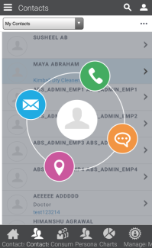

Elasticsearch Integration

Siebel CRM will include a number of enhancements to Siebel’s Advanced Search functionality:

- Integration with Elasticsearch embedded within Siebel (so a third-party REST adapter is not required for Elasticsearch integration).
- Siebel CRM will provide a utility to help previous Oracle Secure Enterprise Search customers with the migration of their SES configuration to Elasticsearch.
- Support for searching attachment content for Elasticsearch and third-party search engines.
- Auto-complete supported out of the box with the embedded Elasticsearch implementation.
- Search supported in non-traditional categories (for example Sales Catalog).
INNOVATION THEMES

Siebel CRM innovation follows core themes that provide a cohesive product roadmap. The primary themes are described below:

Autonomous CRM
The path to an autonomous or self-driving Siebel CRM system is multi-faceted and relies heavily on making intelligent use of data and new technologies:

Process Automation - The single Siebel CRM data model, business services and integration architecture provide a rich platform for automating existing business processes. Our goal is to enable customers to make use of existing customer data and business processes for intelligent automation. This requires the ability to capture usage data, perform analysis and use the insights to guide manual and automated user journeys. Usage data will also provision the creation of task maps to help occasional and novice users navigate through the Siebel CRM application. For microservices and IoT driven processes, it is necessary to enable the independent execution of business processes in Siebel CRM that can execute without User Interface (UI) context.

Artificial Intelligence & Machine Learning - Enabling Siebel CRM data and processes to leverage new technologies such as artificial intelligence and machine learning is a crucial part of our autonomous CRM vision. Applications such as Chatbots and Digital Assistants that can interact with data in Siebel CRM to provide new interactive experiences. Providing business insights with intuitive dashboards that provide descriptive analytics to the end user and utilizing application-definition metadata to minimize or eliminate the cost of building such dashboards. Adding support for the Oracle Autonomous Database and Advanced Analytics with Siebel CRM application to make use of machine learning functionality.

Business Agility

Agile – The Siebel CRM application is now easier than ever to maintain and update. Our continued focus on agility enables enterprises to adapt to business challenges quicker than ever and our goal is to continue to reduce application downtime by providing the capability to make changes to the application in real-time.

Developers – Siebel CRM now provides a modern developer experience to configure, manage, and deploy the application, at the same time enabling parallel, collaborative, and distributed team development. A built in, simple to use Test Automation Suite provides automated, lights-out testing, saving lots of time and money.

Open UI – The Siebel CRM Open UI framework provides the flexibility to design and deploy the application to be specific to your business and customer needs. The ability to deploy the application across a broad variety of browsers and devices on an open and flexible technology stack saves money and reduces the total cost of ownership (TCO). Open UI provides the ability to deliver employee facing applications and customer portals securely over the internet.

Cloud Ready – Siebel CRM is complementary to Oracle cloud applications. Siebel CRM allows your business to take a flexible approach to your cloud transition by catering to cloud requirements for a variety of stake holders and business requirements. Siebel CRM provides a variety of cloud capabilities:
- Siebel CRM can be hosted in public, private, or partner clouds for employee, partner, and/or customer facing applications. Siebel CRM can also be hosted on premise. This allows for optimization of deployment preferences and protection of the most valuable asset: customer data.
- Siebel CRM on-premise or hosted deployments can integrate with Oracle cloud applications via a number of available integrations
- Siebel CRM interfaces can all be run securely over the internet for Open UI, Siebel Mobile, and Siebel EAI interfaces
- Siebel CRM provides Sales, Service, Marketing, Loyalty, and Master Data Management (MDM) as an integrated source of truth in the cloud
- For sophisticated customers and partners Siebel CRM now supports multitenant database support on the Oracle 12c database.
- The capability to provision and deploy individual parts of the Siebel CRM topology using the Siebel Management Console (SMC) was delivered with Innovation Pack 2017. SMC uses configuration APIs exposed by Siebel CRM. The web based application for provisioning and deploying Siebel CRM via APIs provides the possibility to configure a Siebel CRM topology in the Cloud.

With Siebel CRM, you can confidently take your investment to the next level and host your application in the most suitable cloud deployment model for your enterprise. Siebel CRM can integrate with Oracle Sales Cloud, Service Cloud, and other Oracle ecosystem cloud products to create complete and memorable customer experiences. Oracle offers cloud hosting options for Siebel CRM today. Other partners also support cloud-hosted options.

Customer Experience

Open UI – The Siebel CRM Open UI framework continues to evolve and be enhanced allowing you to create your own tailored user experience specific to your users and your organization.

User Experience – Applications are enhanced for mobile usability and to take advantage of the responsive Open UI framework, creating a better user experience for each employee and for mobile and tablet use.

Mobile – Siebel Mobile enables your application to be used on any mobile device and to be accessible from anywhere. The application automatically recognizes and adapts according to the device. Siebel CRM is enabled for the new generation of mobile usage.

Social – The pervasive nature of social media and customers’ ongoing interactions across this channel illustrate the need for an updated and complete 360° view of your customers. Siebel CRM innovations with Master Data Management represent progressive steps to achieve that golden customer record for your organization.

Industry Innovation
Best of Breed – Siebel CRM’s deep industry solutions continue to be extended to leverage the best-of-breed cloud services to the Siebel ecosystem, such as innovations in industry, mobile solutions, and Oracle’s CX products.

Open UI – The flexibility of Siebel Open UI allows applications to adopt new integrated cloud solutions easily and to leverage Oracle’s CX Suite.
AUTONOMOUS CRM

The automation imperative continues to require CRM systems to focus on superior customer experience. From the manual digital phase (self-service, mobile) to the increasingly data intensive and automated (Social, IoT), we are being driven to position Siebel CRM on the combination of usage data with pre-built processes. The automation of processes is now manifest in the long-term roadmap for Siebel CRM.

Business Process Discovery

Data mining is the first step in the Process Automation journey. For many years, Siebel CRM has been a repository for rich transactional customer data for Opportunities, Service Requests, Products, etc. captured through different channels. Siebel CRM is being extended to capture process data from user journeys. Usage Pattern Tracking (UPT) records user events. With Business Process Discovery, the data captured by UPT is transformed via Process Discoverer into structured process flows. This recorded data can be analyzed for added insights e.g. what’s the click stream that a top performing call center agent used to reduce call handling time.

Multiple use cases arise from the availability of structured process data:
- Analyzing process data for process mining
- Creating user training content
- Producing iHelp content
- Generating tasks for the Task Based UI
- Constructing task-based flows and automatically creating microservices from recorded processes

The Process Discoverer can be run in Unit or Bulk mode.

In Unit Mode, a single process is recorded in the Siebel CRM user interface by an expert user to create the process flow. This data is then used for “Model Process Use Cases”, e.g., creating application help that will guide other users while performing the same task.

In Bulk Mode, a background process captures the data for a set of users for a longer duration (months or even years). Then, based on the delimiters defined by business analysts, the Process Discoverer separates out complete processes from the noise, allowing training, help, or task flows to be generated using the best approach derived from the most productive and efficient users.

Business Process Automation
Following Business Process Discovery and the analysis of recorded data, the optimum business process flows can then be automated. Automated Business Processes will require continuous monitoring to ensure accuracy and continual optimization.
Test Automation
The Test Automation framework is to be further enhanced, improving usability and agility with new Test Automation and Test Management features.

Creating Automated Tests
New features related to the creation of automated tests:

- Extend recording of click streams from Unit mode (test script by test script) to continuous or batch mode. In batch mode, recording can be enabled by setting preferences and you can record a set of flows without having to click Start and End for each flow. Recording mode can be disabled when required. All actions from login to logout get recorded.
- Limit recording of click streams to specific Users, Responsibilities, or Application modules
- Persist all parameters configured for scheduling automation batch execution, paving the way for easy replication and reuse
- Provide for more fields on test scripts to capture additional details of each test case, such as prerequisites, execution steps, input data, expected output, and post-processing.
- Data Driven Tests:
  - Data tables extend test scripts capability to test different input values for same functional flow. A generic framework will be available to define custom data tables and link them with test scripts. Testers will be able to define set of logical data tables, link them with specific application fields used across different test scripts, and import/export data to and from data tables
  - Parameterize tests to run the same flow with different values by defining data sets independently and associating with those data sets with required tests.
  - During batch execution, test scripts associated with data sets will be run repeatedly until all sets of values are covered.
  - Data sets can be maintained independently and reused across different tests

REST API support for Test Automation
In order to automate tests that leverage the Siebel CRM REST interface, ‘REST Assured’ tools will be supported with a Keyword-driven framework. The framework will be enhanced to execute REST API test scripts and bring back test results into Siebel CRM. The enhancements will allow interlacing REST API calls among UI Test Scripts, and build independent REST API based Test Scripts.

This extends Siebel CRM Test Automation capabilities to include REST test scripts, and saves manual efforts on separate execution and integrating test results.

Performance Scalability and Reliability
To increase reusability of the PSR (Performance Scalability and Reliability) load scripts across builds, platforms and databases, the Siebel CRM correlation library module is redesigned to align with Open UI standards of using automation attributes, which are Object Types and Repository Names. This will ensure the load testing automation scripts can be reused across builds, versions, platforms and databases.

Oracle Autonomous Database
Oracle Autonomous Database support for the Siebel CRM application is planned. This will allow customers to run their existing Siebel CRM application on the autonomous database platform (ATP) that is expected to deliver the key benefits of ATP:
- No Human Labor: Database automatically upgrades, patches, and tunes itself while running; automates security updates with no downtime window required.
- No Human Error: SLA guarantees 99.995% reliability and availability, which minimizes costly planned and unplanned downtime to less than 30 minutes a year.
- No Manual Performance Tuning: Database consumes less compute and storage because of machine learning and automatic compression. Combined with lower manual admin costs, Oracle offers even bigger cost savings.

Note: This planned certification will be on the latest available Siebel CRM version/ update at time of certification. Older Siebel CRM versions will not be certified for Autonomous.

BUSINESS AGILITY

Siebel Composer Evolution
Siebel Composer continues to evolve, with new features detailed below.
Siebel Web Tools
As Siebel Web Tools continues to evolve, all functionality currently in Siebel Tools will be provided in Siebel Web Tools and once complete Siebel Tools will be retired. The following features are planned for delivery:
- Script Editors and Debuggers for both Browser and Server Scripts
- Workflow Editor and Simulator in Workspaces
- Taskflow Editor in Workspaces
- Object Creation Wizards
- Functionality to create common visualizations such as Charts, Infolets, Timelines, etc.
- Continuous enhancements to Workspace management e.g.:
- Deletion and archiving of integration Workspaces - ability to delete an integration workspace (including all its child developer Workspaces)

Runtime Repository Version Activation and Rollback
This provides the ability to rollback to a previous version of the Runtime Repository and versioned seed data, such as LOVs, in the event that an issue is discovered after a release has been promoted to the production environment.

Parallel Deployment support for Batch Components (e.g., WFProcMgr, etc.)
Provides the ability for the workspace context to be maintained when making a server request. For example, if a developer is making changes to a workflow and that workflow is invoked asynchronously via Workflow Process Manager, the user should be able to inspect a workspace in an Object Manager and when the workflow is invoked, the Workflow Process Manager will use that same workspace.

Modifications to LOV Management
Provides for the ability to modify LOVs in bulk through EIM and REST, as well as the ability to edit LOVs in directly within the User Interface in both Design Repository (DR) and Runtime Repository-only (RR) environments.

Continuous Integration, Continuous Delivery
New features planned to improve the CI/CD capabilities of Siebel CRM include:

Support for Development, Testing, Integration and Deployment of (OpenUI) Web Artefacts such as JavaScript or CSS Files, within the context of Workspaces, to facilitate a uniform developer experience across all Siebel Development artefacts, which include both repository and web artefacts.
- Ability to author and test web file changes in a Developer Workspace
- Ability to integrate web file changes to an integration Workspace
- Ability to automate deployment of web files to Production

- Ability to run multiple versions of Siebel CRM within the single managed topology – this will address more complex parallel development requirements.
- E.g., Production environment running on 18.10, Development environment running on 19.1.
- Manifest Improvements - Ability to switch off downloads of UI framework components to reduce footprint and potentially lead to improved performance.
- Manifest validation logic to prevent page load errors following an upgrade
- he ability to update web files, and synchronize them to the final deployment location. This solution will consider the necessary flexibility of deployment location as per modern web architectures e.g. deployment of web files on a CDN.

Siebel CRM on Docker
Siebel CRM Dockerfiles to facilitate container builds are already available on the Siebel CRM Github repository. These are not directly supported by Oracle, but are provided to aid customers investigating Siebel CRM and Docker. Best-effort support is made via the issues page on the Github repository.

Docker Delivery via EEStore/Github - Oracle plans to begin releasing Docker images for the Siebel CRM application. The images will be made available initially on Oracle Cloud Marketplace (OCI) and then on the Docker Hub. Customers can take advantage of utilizing this new and easier way to deploy Siebel CRM instances once they are made available. These images will only be made available starting with the Siebel CRM 19.x Updates. Note: there are no plans for older Siebel CRM versions to be made available as Docker containers.

CI/CD Improvements with Docker - Ability to support two instances of Siebel Docker environments deploying and running in parallel via a CI/CD pipeline.

Seamless Repository Delivery Framework
Provides for the delivery of new features without requiring Incremental Repository Merge.

Dynamic Siebel Management Console Security Profile Configuration
Provide the ability for the Siebel Management Console to dynamically reconfigure database connections and authentication, allowing flexibility in re-configuration in support of lower TCO.

Diagnostics
Ability to export/import Zookeeper configuration for use when rebuilding or recreating environments supports replicating environments between dev test and production and to reproduce environments remotely in support of lower TCO.

Application Migration
The Application Migration framework will be further enhanced to provide the following capabilities:
Effective Start Date for Runtime Repository Versions
When migrating a Runtime Repository between environments, it will be possible to specify an activation date and time so that a migrated version of the metadata can be scheduled to take effect at a future date instead of taking effect immediately.

Rollback Support for Runtime Repository
The Runtime Repository will provide support rollback, enabling administrators to quickly and easily rollback to the last known good version of the repository in the event that any major issues are encountered or reported in the latest deployed version.
Additionally, there will be a provision to activate any specific version of the Runtime Repository.

Migration Application Logging for Dev2Prod
Siebel Migration application has enhanced logging mechanism for troubleshooting and diagnosing any step or resource in the migration execution process. The error messages in the migration log files will be improved and more meaningful. Siebel Migration application will support migration across cloud infrastructures across vendors with reliable database connection pooling.

Siebel CRM on Cloud Migration Transparency
For the Siebel Migration application to function in a heterogeneous cloud environment requires a specialized way of handling database connection pooling. This feature will ensure the migration application will work in IAAS/PAAS architecture for setup and configuration.

Siebel Approval Manager
- Siebel Approval Manager (SAM) -- the development governance tool for Siebel CRM -- will be enhanced to provide the following support:
- Support for use of SAM for the DB2 platforms
- REST API support for publishing Workspaces delivered through SAM
- Administration usability enhancements including profile cloning and intelligent defaults
- Ability to validate multiple field values together (in previous releases, only single field validation is available)
- Additional configurable email templates
- REST API examples for more third-party systems such as Jira, Rally, etc.

REST API Enhancements
Features will be delivered to enhance the Siebel CRM REST API:
- Ability to Version REST APIs
- Support for REST Attachments
- Support for single request CRUD of entire Resource Hierarchy – This can facilitate insertion of Business Component records in an entire Business Object in one request.
- Support for single request CRUD of multiple resources of same type – This can facilitate insertion of multiple records of a Business Component in one request.
- Support for Hierarchical Business Components as REST resources

- Automation of CRUD APIs - Dynamic IOs
- Record Level Access Control
- Automatic or Flip of a Switch exposure of Business Objects as REST resources, without detailed explicit configuration of Integration Objects.
- eScripting JSON support, JSON manipulation API in the Siebel CRM scripting library
- Simplified payload structure for business services, intuitively mapped to the input and output for the given Business Service, allowing for easy synthesis of Business Service invocation payloads.

Exposing Siebel Management Console REST APIs
Expose standard based REST API's of Siebel Management Console. Provide validation throughout management lifecycle including profile creation, deployment and configuration.

Oauth/Open ID and SAML Integration
To ease deployment of SAML a Service provider and simplified integration for SAML 2.0 will be introduced. Oracle will also provide better Oauth integration options. Oauth and SAML will have improved documentation for popular integrations with Identity Cloud Service from Oracle.

Siebel Server Sync for Exchange (SSSE)
Siebel Server will be integrated to Microsoft Exchange Server via Office 365 through SSSE (Siebel Server Sync for Microsoft Exchange). This will enable customers to deploy Exchange Server in the cloud (part of O365) and be able to connect to Siebel server to take advantage of the integration of Exchange Server with the Siebel Calendar to ensure all Siebel appointments/tasks are in sync with Exchange.

